Alternative/Similar Systems

This section will look at two systems that are similar to my project, namely ABNER and Citeology. It will provide a brief introduction to, and an evaluation of, each of these systems.

ABNER

ABNER, which stands for A Biomedical Named Entity Recogniser, is a Java based, open source NER tool designed to analyse molecular biology texts. Originally developed in 2004 by Burr Settles at the University of Wisconsin-Madison part of the NLPBA/BioNLP 2004 Shared Task challenge, its current version, 1.5, was released in 2005.

ABNER consists of a simple Java GUI and uses a statistical machine learning approach to identify and annotate named entities such as proteins, DNA, RNA and cell types. It is bundled as a Java archive (JAR) and includes a Java API to allow it be incorporated in to other applications.

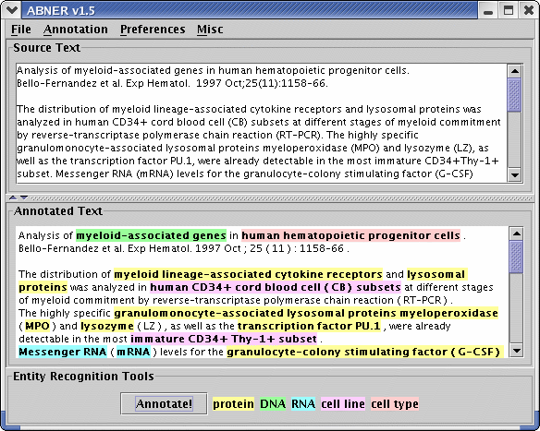

Figure 3: ABNER screenshot

Evaluation

Usability: ABNER's simple interface is very easy to use. It has two text boxes, one for the source text and another for the annotated text. It also features four drop down menus at the top of the window.

File has options for starting annotation of a new file, opening a text file containing source text to annotated and the option to save annotated text in one of three formats.

The annotation menu has two options. The first is to annotate the current document, which can also be done by means of an 'Annotate' button at the bottom of the interface. The second option is to perform a batch annotation of all files stored in a directory. These files can be output in the same three formats available in the save function.

The preferences menu allows users to choose from 2 different annotation models. The first is NLPBA, which will annotate 5 different classes of entities, protein, DNA, RNA, cell line and cell type. The second is BioCreative which will annotate proteins only.

The final menu is misc. This menu allows for one of three different demo texts to be loaded in to the source box. This menu also contains an 'About ABNER' option, which provides version and licensing information along with a link to the ABNER website.

Along side the ability to load from a file and generate demo text, text can also be manually entered in to the source text box.

Clarity of Data: ABNER presents the annotated data in a very clear way. The five different entities are colour coded in the annotated text box. A legend presented at the bottom of the interface lists the 5 entities highlighted by the colour representing them.

Documentation: There is no documentation for ABNER. The website lists the features available and provides the screenshot shown above. However the simple interface and ease of use easily counteracts the lack of documentation.

F1 Measure: ABNER has two F1 scores for each model. It has a standard F1 score and soft F1 score. Given length and complexity of the named entities it is tagging the soft F1 score allows for matching one boundary of the entity with a one-word error on the other side being tolerated.

NLPBA F1: 70.50% Soft F1: 82.00%
BioCreative F1: 69.90% Soft F1: 83.70%

Given the complexity of named entities in molecular biology texts, these F1 scores are considered roughly state of the art.

Citeology

Citeology is an interactive visualisation tool to show the relationship between research papers based on their citations. Citeology was developed as a Java applet by Justin Matejka, George Fitzmaurice and Tovi Grossman at Autodesk Research, as part of Autodesk's Visualization Project.

Citeology runs as a Java applet on the Citeology webpage and allows users to select one of the 3502 papers from both the ACM Conference on Human Factors in Computing Systems (CHI) and ACM Symposium on User Interface Software and Technology (UIST) conferences, between the years 1982 and 2010. The applet then shows a graph connecting all the older papers referenced in the selected paper along with all the papers since that have referenced the selected paper.
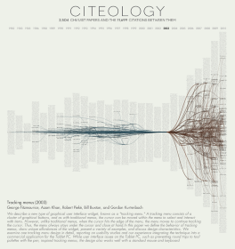

Figure : Citeology Screenshot

Evaluation

Usability: Citeology is quite easy to use. There are 27 columns on screen each with a year on top. These columns contain the titles of all the papers published at the CHI and USIT conferences for the that year. Hovering over a title will display the paper's full title in a tooltip box. Clicking on a paper will select it and will show the paper's ancestors (paper that it has referenced) and descendants (papers that reference it). The ancestors a connected to the paper with blue lines while the descendants are connected using red lines.

There are buttons in the top left hand corner to set the number of generations of descendants and ancestors to view. First generation ancestors and descendants are papers directly referenced by, or that directly reference, the selected paper. Further generations of ancestors and descendants are paper referenced by ancestors or papers that reference descendants.

There is also a 'Find Paper' search box in the top left corner. This allows the user to directly search for a specific paper and will begin to automatically suggest paper titles based on letters typed by the user.

There are three buttons at the bottom of the interface. The first is the 'Visit Paper Page' button which links users to the selected paper on the ACM's digital library website. The next button allows the user to generate a high-resolution pdf of the current graph. The third button allows the user to copy a link to the specific graph they have generated.

Below these three buttons the title, authors and beginning of the selected paper are displayed.

Clarity of Data: The major drawback of Citeology is the lack of a zoom function. The data is too difficult to read in the applet itself. The titles of each paper are impossible to read without the tooltip popup.

The graphing itself is well done and while showing three or more generations often leads to a mass of lines, this in itself demonstrates the interdependency of these paper and how they build upon each other. The ability to show one, then two and more generations in a sequence is visually impressive but due to the lack of clarity a user would have to generate a pdf to show for each iteration in order to clearly see the differences.

Documentation: The interface is quite easy and intuitive to use. Citeology does however provide documentation on how to use the applet, including explaining keyboard shortcuts for certain task. This is visible just below the applet.

